Live Casino Report and Setting in Accounting System

Setting
- Add ‘Enable Live Casino’ to all levels
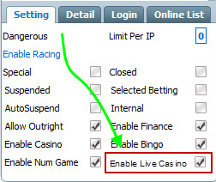
- Click on the checkbox of ‘Enable Live Casino’ will have the option to check the particular downline or with all his downlines. Example, checkbox of Super’s downlines will only available to tick or untick if checkbox of Super is checked.
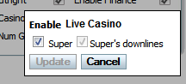

Detail
- Add ‘Edit Live Casino’
- The feature similar to the description in Live Casino Agent System Spec.
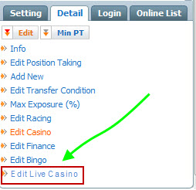

Settlement
- Able to void and refund completed game.
- Incomplete game that void and refund through dealer system will record as well.
- Able to change result, recalculate and resettle. (Phase 2, mainly for Roulette and Sicbo)

Settlement > Result
- Add live casino result in the leagues dropdown list with the option ‘All Live Casino’, ‘Live Casino – Baccarat Table 01’, ‘Live Casino – Roulette Table 04’ and etc.
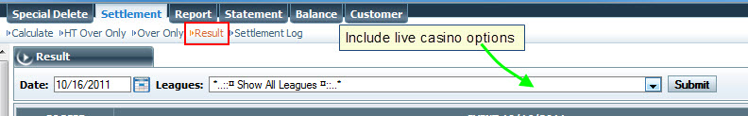

Customer > Super/Master List
- Add ‘Live Casino’ in ‘Edit’ pop out list.
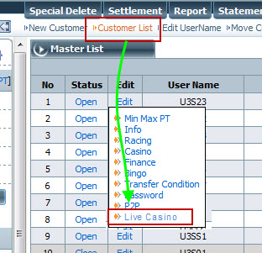

Customer > View PT
- Include live casino selection when choose ‘PT’.
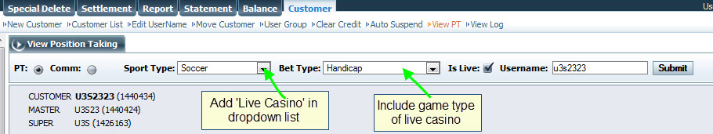
- Add a column to show ‘Live Casino’ commission.
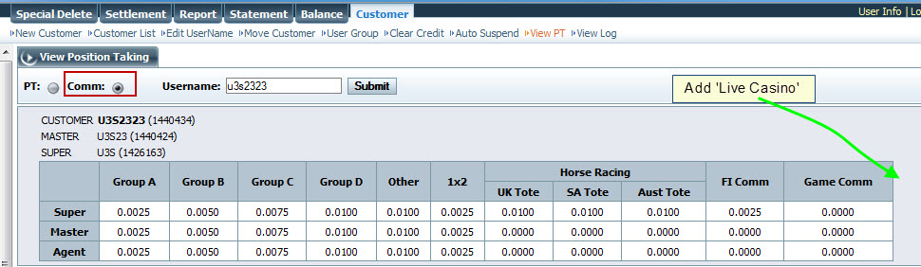

Report

Add in Report for “Live Casino”

Type of report needed
- Search filter
- Win loss by Game Table
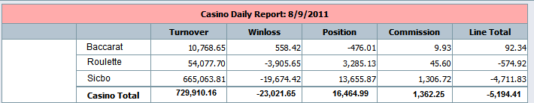

- Win loss by Date
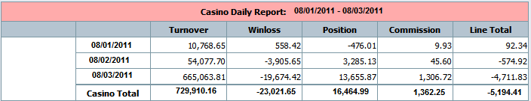
- Win loss by Currency


